Now we have created our table it's time to enter some data. So, to be able to enter data into our table.

go to the utilities menu, go down to the table contents option and select create entries.

This will now take you to a data entry screen, that has automatically been generated for us.

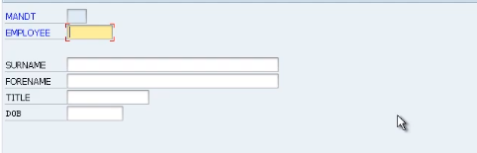

Now before we enter some data, you'll notice, the field names of the actual technical names of the field that we declared. For each field, we entered some field labels. So, I'll show you how to change the look of the screen so the field labels appear instead of the technical names.

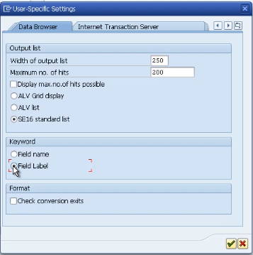

Go to the settings menu and select user parameters. Now this option allows you to tailor how tables look specifically for your user ID. So, click field labels radio button and click the continue key. Now you can see the field labels have come back just as we define them and create in the table.

So now let's enter some records.

the system automatically validated every field to ensure we entered the correct values.

So just click the save button. Check the status bar at the bottom and you can see the record has successfully been saved. So, what we're going to do now is just click the reset button and it'll reset these fields back to their default values. And we'll enter our second record.